APPENDIX A: USING EXCEL HELPER

The Excel Helper is a free ware used to convert the excel files (usually Excel Spread Sheets are used to create the test tables) into tab separated files (usually WRAFS accepts tab separated files as input, but WRAFS can be made to accept files in CSV format also). The following are the steps in using Excel Helper.

Step 1: Start Excel Helper (Start>Excel Helper)

Step 2: The following window appears

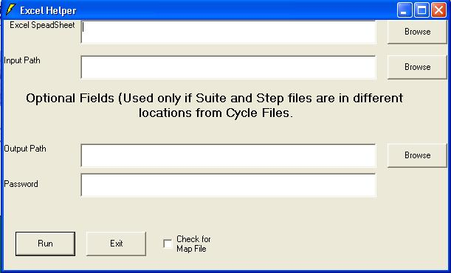
Excel Helper Window

Step 3: Specify the Excel Spread Sheet (For E.g. CycleDriver.xls) that is to be converted into tab separated file. (Make use of the “Browse” button)

Step 4: Specify the path where the input Excel Spread Sheet is stored. (For E.g. C:\Test\Others\Datapool9)
Step 5: Specify the output path where the tab separated file is to be stored. (For E.g. C:\Test\Others\Datapool9\Cycle)

Step 6: Usually we need not specify any password (leave it blank), need not check the “Check for Map File” radio button also

Step 7: Click “Run” button

Step 8: After completing the above steps, the resultant window would be like the following figure,
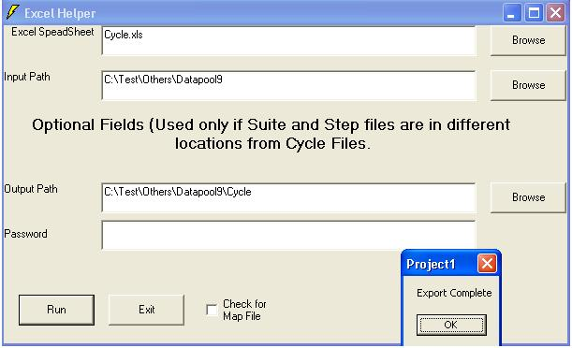
Final step in the conversion process
Step 9: Click “OK” in the “Project1” window & repeat the above process from step3 for other tables
Note: Make sure that all the test tables (Cycle, Suite and Step) have been converted into tab separated files, before executing the test.

